**QUERIES**

**QUERY 1**

**User input the passenger’s last name and first name and retrieve all trains they are booked on.**

SELECT Train."Train Name"

FROM Train

JOIN Booked ON Passenger.SSN = Booked.Passanger_ssn

JOIN Passenger ON Booked.Train_Number = Train."Train Number"

WHERE Passenger.first_name={first_name}

AND Passenger.last_name={last_name};

**QUERY 2**

**User input the data and the list of passengers travelling on entered day with confirmed tickets displays on UI.**

SELECT Passenger.first_name, Passenger.last_name  
FROM Passenger JOIN Booked ON Passenger.SSN = Booked.Passanger_ssn   
JOIN Train ON Booked.Train_Number = Train."Train Number"  
JOIN Train_Status ON Train.\"Train Name\" = Train_Status.TrainName  
WHERE Train_Status.TrainDate = {travel_date}  
AND Booked.Staus = 'Booked'

**QUERY 3**

**User input age of the passenger (50-60) and UI display the train information (Train Number, Train Name, Source and Destination) and passenger information (Name, Address Category, ticket Status) of passengers who are between the ages of 50 to 60.**

SELECT   
 t."Train Number",   
 t."Train Name",   
 t."Source Station",   
 t."Destination Station",   
 p.first_name,   
 p.last_name,   
 p.address,   
 b.Ticket_Type,   
 b.Staus  
FROM   
 Passenger p   
 JOIN Booked b ON p.SSN = b.Passanger_ssn   
 JOIN Train t ON b.Train_Number = t."Train Number"  
WHERE   
 CAST(substr(p.bdate, -2) AS INTEGER) BETWEEN {last_two_end} AND {last_two_start}

**QUERY 4**

**List all the train names along with the count of passengers it is carrying.**

SELECT Train."Train Name" , COUNT(*) FROM Booked JOIN Train ON Booked.Train_Number = Train."Train Number" GROUP BY Train."Train Name"

**QUERY 5**

**Enter the train name and retrieve all passengers with confirmed status travelling in that train.**

SELECT Passenger.first_name, Passenger.last_name FROM Booked JOIN Passenger ON Booked.Passanger_ssn = Passenger.SSN WHERE Booked.Train_Number=(SELECT "Train Number" FROM Train WHERE "Train Name"={train_name}) AND Booked.Staus='Booked'

**QUERY 6**

**User Cancel a ticket (delete a record) and show that passenger in waiting list get ticket confirmed.**

SELECT Passanger_ssn   
 FROM booked   
 WHERE Ticket_Type = (  
 SELECT Ticket_Type   
 FROM booked   
 WHERE Passanger_ssn = {passenger_id})   
 AND Train_Number = (  
 SELECT Train_Number   
 FROM booked   
 WHERE Passanger_ssn = {passenger_id})   
 AND Staus = 'WaitL'   
 LIMIT 1

UPDATE Booked  
SET Staus = 'Booked'  
WHERE Passanger_ssn = (  
 SELECT Passanger_ssn  
 FROM Booked  
 WHERE Ticket_Type = (  
 SELECT Ticket_Type  
 FROM Booked  
 WHERE Passanger_ssn = {passenger_id}  
 )  
 AND Train_Number = (  
 SELECT Train_Number  
 FROM Booked  
 WHERE Passanger_ssn = {passenger_id}  
 )  
 AND Staus = 'WaitL'  
 AND EXISTS (  
 SELECT 1  
 FROM Train_Status ts  
 JOIN Train t ON TRIM(t."Train Name") = TRIM(ts.TrainName)  
 WHERE ts.TrainDate = '{travel_date}'  
 AND t."Train Number" = (SELECT Train_Number FROM Booked WHERE Passanger_ssn = '{passenger_id}')  
 AND (ts.PremiumSeatsAvailable > 0 OR ts.GenSeatsAvailable > 0)  
 )  
 LIMIT 1  
);

DELETE FROM Booked WHERE Passanger_ssn = {passenger_id}

**INSTRUCTIONS**

**Connecting database using sqlite3:**

* The database is created using Python code.
* All the CSV files are kept in the same folder where the python environment is going to run.
* Run the Python function table_creation_insertion().
* It will retrieve column names from the CSV file first, along with their column values.
* It creates a table with the table name as the file name.
* For data types, we have defined a Python function get_column_datatypes().
* This function reads column values and determines the column data type using a predefined Python function.
* After table creation, we have an insert function named insert_data().
* It reads data from the CSV file and dynamically inserts it into the table created using the above creation function.

Once the function completed we can perform SQL Queries in the python created tables.

**Booked Table:**

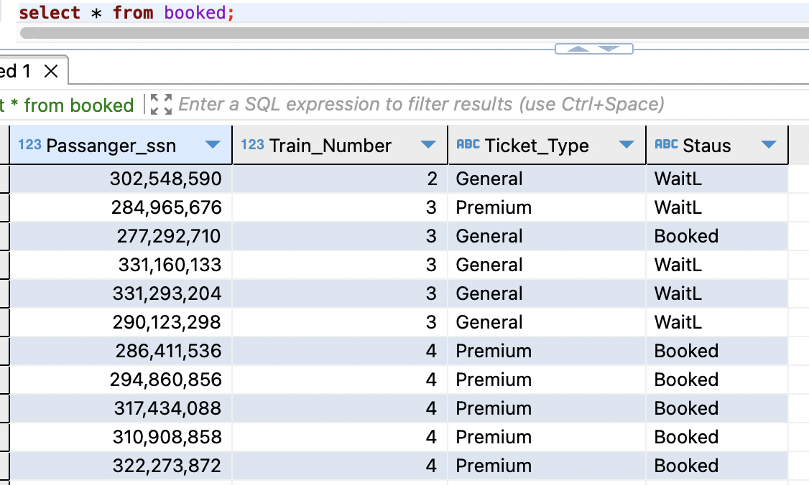

**Train Table:**

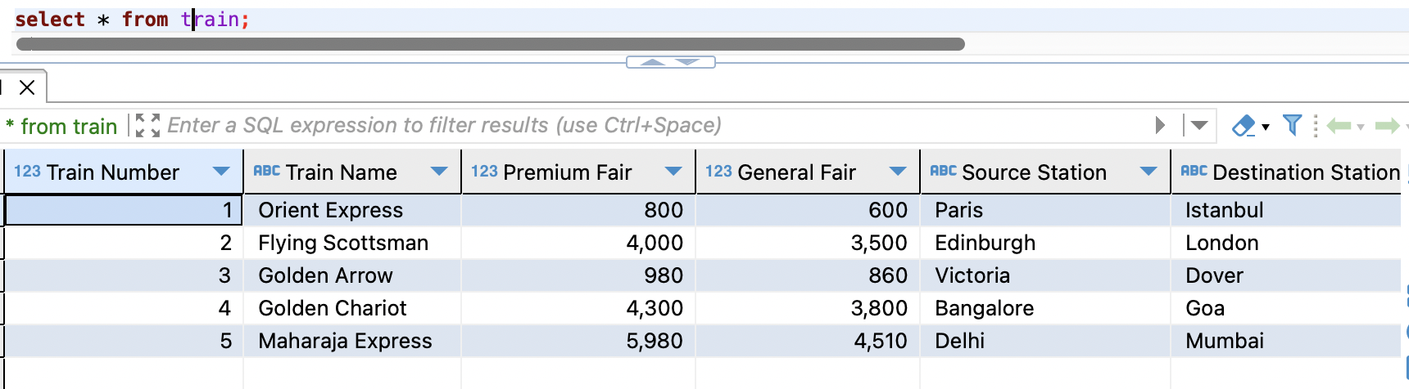

**Train Status Table:**

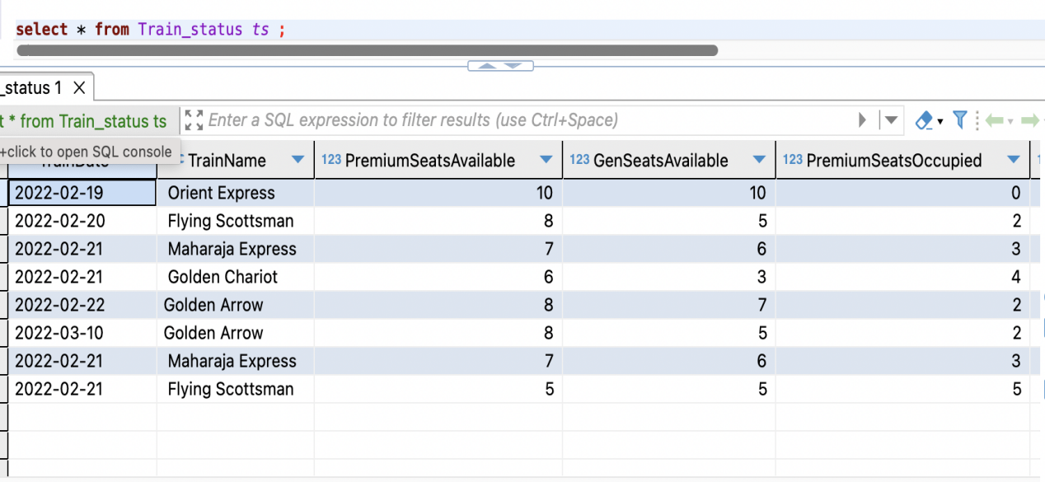

**Passenger Table:**

